

**North South University**

# Department of Electrical & Computer Engineering

**LAB REPORT**

Course Code: EEE141L

Course Title: Electrical Circuits I Lab

Course Instructor: Dr. Mohammad Abdul Matin (Mtn)

Experiment Number: 1

Experiment Name:

|  |
| --- |
| Ohm’s Law, KVL, and Voltage Divider Rule using Series Circuit |

Experiment Date: 4/3/2021

Date of Submission: 10/3/2021

Section: 3

Submitted To: Tabia Hossain

|  |  |
| --- | --- |
| Submitted By | Score |
| Student Name and ID:  1. Md. Rifat Ahmed - 1931725042 |  |

**Objectives:**

• Find the resistance of a resistor from its color code.

• Measure voltage, current and power values using OrCAD software.

• Verify the validity of Ohm’s Law.

• Test the voltage divider rule in a series circuit.

• Validate the voltage divider rules.

• Verify Kirchhoff’s voltage law.

**List of Equipment:**

• OrCAD Software

• PSpice Software

• Resistors (3.3kΩ, 4.7kΩ, 5.6kΩ)

• Connecting Wires

**Theory:**

**Ohm’s Law:**

According to Ohm’s law the current going through a conductor between two points is directly proportional to the voltage across the two points.

V ∝ I

So, the amount of current, I flowing through the resistor is proportional to the voltage, V across the circuit where the resistance works as the proportionality constant for the resistor. So, the mathematical equation stands as,

V = IR

And this resistance R is what resists the flow of current in a circuit which is measured in ohms.

Now using this formula from ohm’s law, we can find the voltage or current or resistance of a circuit if any two of the three values are given.

**Voltage Divider Rule:**

If a series circuit has more than one resistor then their voltage gets divided among the resistors and the higher the resistance the higher voltage drop will occur at that resistor.

And to calculate the voltage drop among the resistors we can use the Voltage Divider Rule where you multiply the resistance of the resistor with the source voltage of the circuit and divide it with the total resistance of the circuit. So, the equation would stand as,

Vm = x Vs

Where, VS is the source voltage, Rm indicates the resistor we’re trying to find the voltage (Vm) at and n indicates the total number of resistors.

Now for example if we want to find the voltage across the two resistors of Figure-1 we can calculate it like this,

V1 = x VS

V2 = x VS

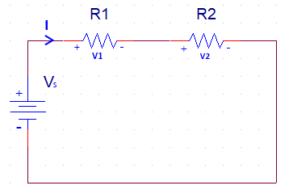

Figure - 1

**Kirchhoff’s Voltage Law (KVL):**

Kirchhoff’s voltage law states that the algebraic sum of all the voltages around a closed loop is zero. Which basically means that the sum of voltage rises and drops should be zero in a closed loop.

Now, according to KVL the sum of total voltage running across the circuit given in Figure-2 is zero.

Applying KVL on Figure-2 we get,

-V1 + V2 + V3 + V4 = 0

=> V1 = V2 + V3 + V4

**؞** According to KVL this indicates that the voltage rise in V1 is equal to the voltage drops in V2, V3 and V4.

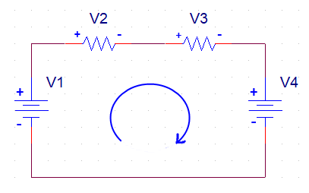

Figure - 2

**Circuit Diagram:**

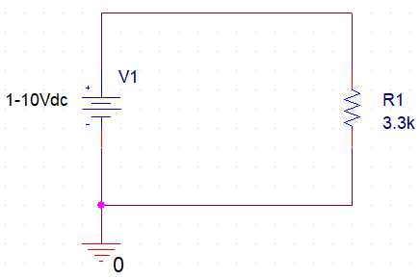

**Circuit – 1 (with 3.3kΩ resistance)**

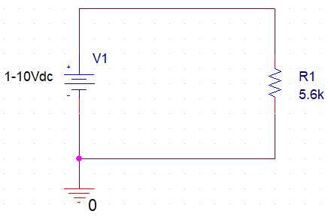

**Circuit – 1 (with 5.6kΩ resistance)**

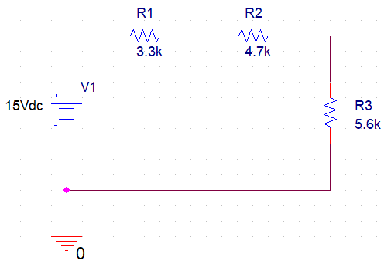

**Circuit - 2**

**Data, Readings and Results:**

**Tables for Experiment 1.1:**

|  |  |  |  |
| --- | --- | --- | --- |
| **3.3kΩ**  **Voltage** | **Experimental Readings** | | |
| **Current, I (mA)** | **Voltage, IR (V)** | **Power, I2R (mW)** |
| 2 | 0.606 | 2.000 | 1.212 |
| 4 | 1.212 | 4.000 | 4.849 |
| 6 | 1.818 | 6.000 | 10.910 |
| 8 | 2.424 | 8.000 | 19.390 |
| 10 | 3.030 | 10.000 | 30.300 |

|  |  |  |  |
| --- | --- | --- | --- |
| **5.6kΩ**  **Voltage** | **Experimental Readings** | | |
| **Current, I (mA)** | **Voltage, IR (V)** | **Power, I2R (mW)** |
| 2 | 0.357 | 2.000 | 0.714 |
| 4 | 0.714 | 4.000 | 2.857 |
| 6 | 1.071 | 6.000 | 6.429 |
| 8 | 1.429 | 8.000 | 11.430 |
| 10 | 1.786 | 10.000 | 17.860 |

**Theoretical values Calculation:**

Given,

VS = 15V

R1 = 3.3kΩ

R2 = 4.7kΩ

R3 = 5.6kΩ

**؞** Total Resistance, RT = R1 + R2 + R3

= 3.3kΩ + 4.7kΩ + 5.6kΩ

= 13.6kΩ

Now, Using Voltage Divider Rule,

**؞** V1 = x VS

= x 15V = 3.640V

**؞** V2 = x VS

= x 15V = 5.184V

**؞** V3 = x VS

= x 15V = 6.176V

**Percentage Error Calculation:**

% Error for VS = X 100%

= X 100% = 0%

% Error for VR1 = X 100% = 0%

% Error for VR2 = X 100% = 0.02%

% Error for VR3 = X 100% = 0.02%

**Tables for Experiment 1.2:**

|  |  |  |  |  |  |  |  |
| --- | --- | --- | --- | --- | --- | --- | --- |
| **Experimental readings** | | | | **Theoretical values** | | | |
| **VS** | **VR1** | **VR2** | **VR3** | **VS** | **VR1** | **VR2** | **VR3** |
| 15 | 3.640 | 5.183 | 6.177 | 15 | 3.640 | 5.184 | 6.176 |
| **% Error** | | | | | | | |
| **VS** | | **VR1** | | **VR2** | | **VR3** | |
| 0% | | 0% | | 0.02% | | 0.02% | |

|  |  |  |
| --- | --- | --- |
| **Potential rise VS** | 15V | **Are the voltage rises and drops equal?** |
| **Potential drops (VR1 + VR2 + VR3)** | 15V | Yes, they are equal |

**Graphical Analysis:**

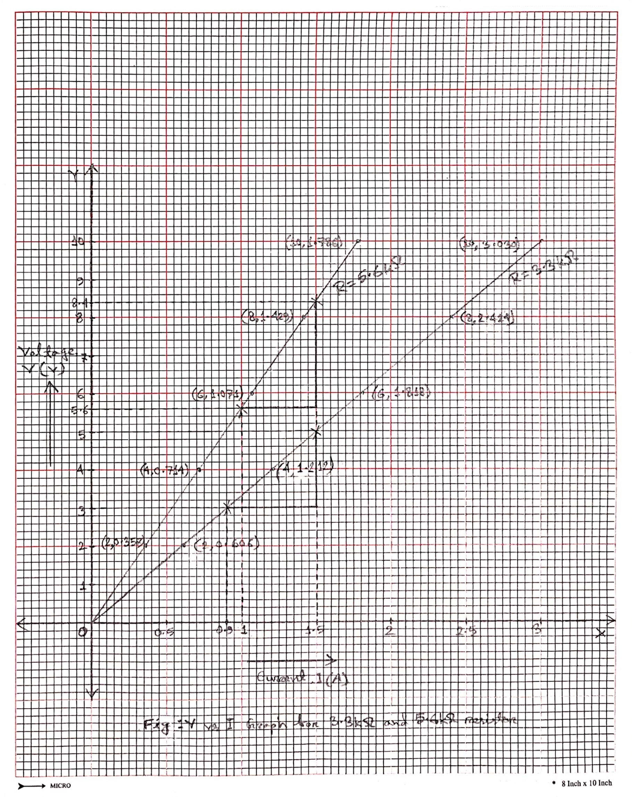

Fig: V vs I Graph (for 3.3kΩ & 5.6kΩ resistor)

**Questions and Answers:**

**Answer of Question 2 (Exp-1.1):**

Yes, my circuit follows ohm’s law.

From ohm’s law we know that V is proportional to I so if V increases, I will also increase and from the experimental readings we can see that with voltage increasing the current is also increasing and from the V vs I graph we can also see that it’s increasing exponentially so it confirms that my circuit follows ohm’s law.

**Answer of Question 3 (Exp-1.1):**

Slope of the first line = = 3.3

**؞** The resistance calculated from the slope of the first line is 3.3kΩ

Slope of the second line = = 5.6

**؞** The resistance calculated from the slope of the second line is 5.6kΩ

Here we can see that the given resistance and the resistance found from the slopes are exactly same so their percent difference is 0.

**Answer of Question 1 (Exp-1.2):**

We’ve already calculated the theoretical values of the table with all the steps in Data, Readings and Results section and the values are as follows,

VS = 15V, VR1 = 3.640, VR2 = 5.184, VR3 = 6.176

And the experimental values we got from OrCAD are,

VS = 15V, VR1 = 3.640, VR2 = 5.183, VR3 = 6.177

Here, we can see that the values of VS and VR1 are exactly same for both theoretical and experimental values while VR2 and VR3 are almost equal. Now according to KVL the sum of all the voltages in a closed circuit should be zero. So now if we add up VS, VR1, VR2, VR3 of our circuit the result should be zero.

Now applying KVL to our circuit we get = -15V + 3.640 + 5.183 + 6.177 = 0.

Here the sum of all the voltages in our circuit is 0 so it is clear that our circuit follows KVL.

**Discussion:**

From this experiment we learned how to create circuits using the OrCAD software then we learned how to measure the values of voltage, current and power using PSpice. We also learned how to find the resistance using the color codes of a resistor. Now coming to the result analysis, our experimental values and the theoretical values were almost same and there wasn’t much deviation between them and because of that we didn’t get much of an error in our results and after using KVL in the 2nd part of our experiment we saw that it also follows KVL. So, the practical results were almost similar to the theoretical results and so it could be said that the practical results were almost the same of what I had expected from the theoretical knowledge. But there were some problems during the experiment like we couldn’t use any actual resistors or circuits to get our data we had to use the OrCAD software to generate the values so it might not be hundred percent accurate with the values we might get by doing the experiment in real life so doing the experiment online without using any actual hardware is a big drawback for our experiment other than that everything else done in this experiment is alright.